Bugs Scribus 1.4.4 (may apply to newer versions if the code wasn't changed)

Hyphenation and right aligned sentences:

A soft hyphen is not placed correctly against the right side of the textframe.

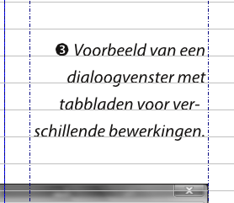

Overview of the special characters used in this small textframe.

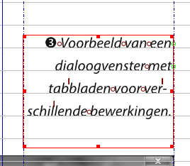

However when Optical margins applied in this case on the right side while using a soft hyphen:

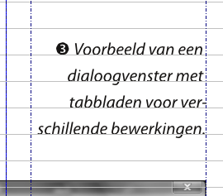

If the soft hyphen is replaced by a hard hyphen the result is as is expected.

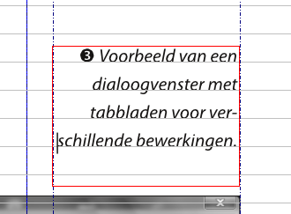

With Optical margins applied on the right side with a hard hyphen:

